"Experience the Magic of Kerala”
(4N/5D)

Discover the breathtaking beauty of Kerala, fondly known as "God's Own Country," on this unforgettable 5 Days / 4 Nights holiday. Explore the mist-covered tea plantations of Munnar, renowned for its scenic landscapes and refreshing climate. Cruise through the tranquil backwaters of Alleppey aboard a traditional houseboat, surrounded by lush coconut groves and charming villages.

Experience the rich heritage and colonial charm of Kochi, home to iconic landmarks and vibrant local culture. This itinerary offers the perfect blend of nature, relaxation, and cultural exploration, making it an ideal getaway for families, couples, and nature enthusiasts seeking a memorable South Indian holiday.

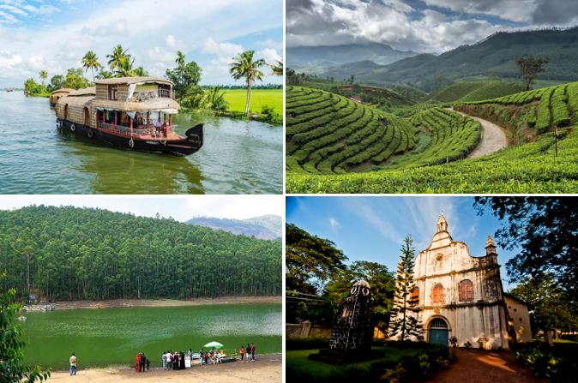

We wish you a happy, safe and unforgettable journey with us

Detailed Itinerary

Day 01: Arrive Kochi – Transfer to Munna

Upon arrival at Cochin International Airport or Ernakulam Railway Station, meet our representative and drive to the picturesque hill station of Munnar. En route, enjoy the scenic beauty of lush green tea plantations, cascading waterfalls, and spice gardens. You may stop at Cheeyappara and Valara Waterfalls (seasonal) for photographs. Upon arrival, check in to the hotel and spend the rest of the evening at leisure. Overnight stay in Munnar.

Day 02: Munnar Sightseeing

After breakfast, embark on a full-day sightseeing tour of Munnar, renowned for its rolling tea gardens and misty hills. Visit popular attractions including Eravikulam National Park (subject to availability), Tea Museum, Mattupetty Dam, Echo Point, Kundala Lake, and Photo Point. Enjoy the breathtaking landscapes and pleasant climate before returning to the hotel. Overnight stay in Munnar.

Day 03: Munnar – Alleppey
After breakfast, check out of the hotel and drive to Alleppey, famously known as the "Venice of the East." Upon arrival, check in to your houseboat or hotel (as per the package). Spend the day cruising through the tranquil backwaters, passing lush paddy fields, coconut groves, charming villages, and traditional Kerala life. Relish delicious local cuisine on board while enjoying the serene surroundings. Overnight stay in Alleppey.
Day 04: Alleppey – Kochi
After breakfast, check out and drive back to Kochi. Upon arrival, explore the city's major attractions including Fort Kochi, Chinese Fishing Nets, St. Francis Church, Santa Cruz Basilica, Mattancherry Palace (Dutch Palace), and the historic Jew Town. In the evening, you may enjoy shopping for spices, handicrafts, and souvenirs before checking in to your hotel. Overnight stay in Kochi.
Day 05: Kochi Departure
After breakfast, check out of the hotel and transfer to Cochin International Airport or Ernakulam Railway Station for your onward journey. Depart with wonderful memories of Kerala's misty hills, serene backwaters, and rich cultural heritage. We wish you a safe journey and hope to welcome you again for another memorable holiday.
Tour ends with unforgettable memories
Destination/Nights | 3* Hotel Name
Munnar /02N
Alleppey /01N | Houseboat
Kochi /01N
HOTELS DETAILS:

Package Cost:

3★ Hotels: Rs. per person (Based on 6 guests – Double Sharing Basis)

Inclusion: -
- Breakfast and Dinner Included.
- 0 DBL Room on sharing based.
- 03 Nights in Accommodation in hotel.
- 01 Night in Super Deluxe Houseboat in Alleppey.
- Assistance on Arrival.
- All Transfers and S.S tours by AC Tempo Traveler [Pick Up Kochi – Drop at Kochi]
Exclusions: -
- 5% GST.
- Flight Tickets are not included.
- Guide.
- Extra meal not included or as per the inclusions given above.
- No extra pickup or drop included for lunch/sightseeing unless otherwise mentioned in the itinerary.

